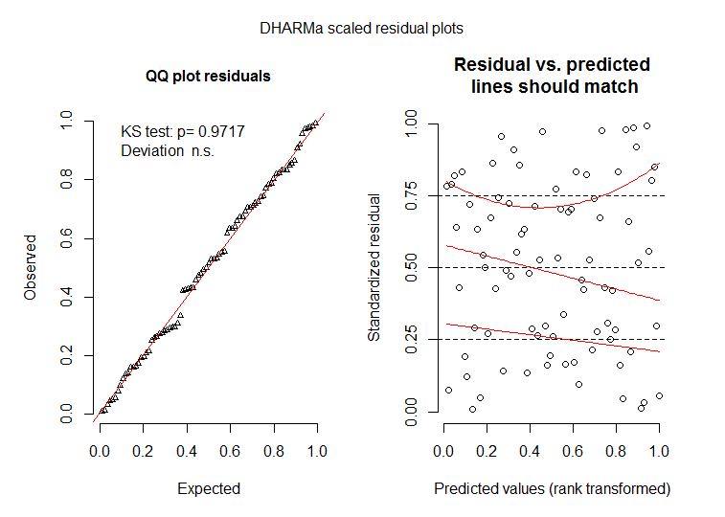A3.4 – QQplot and residual vs predicted plot form crustacean abundance GLMM (plots created using DHARMa package).